Email Capture Pro User Guide

1. Email Capture Pro is designed to work with a Multi-Functional Printer, whenever someone scans from the printer (MFP) to the email address it will be filed to DIKO. To set up DIKO to use with MFP, go to System 🡪 SOP Email Capture Setup

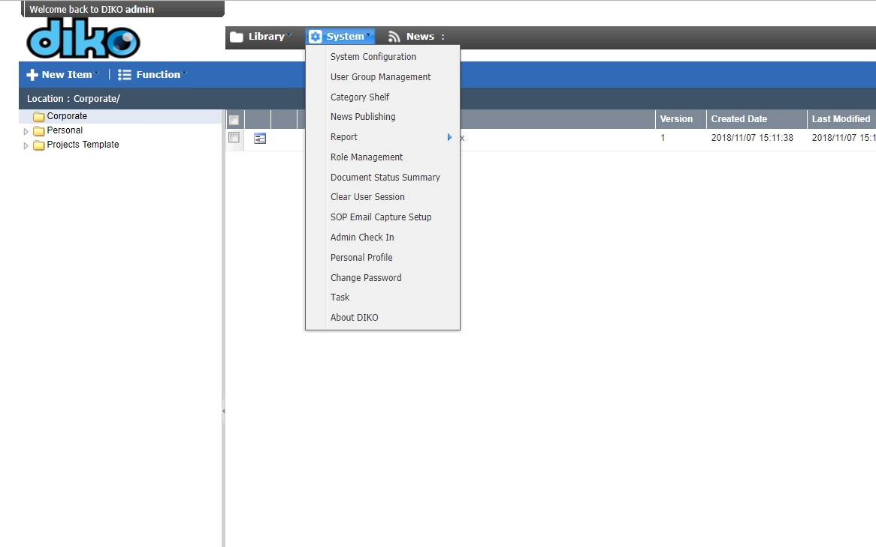

2. Email Capture Pro looks like this, click on "Add Inbox"

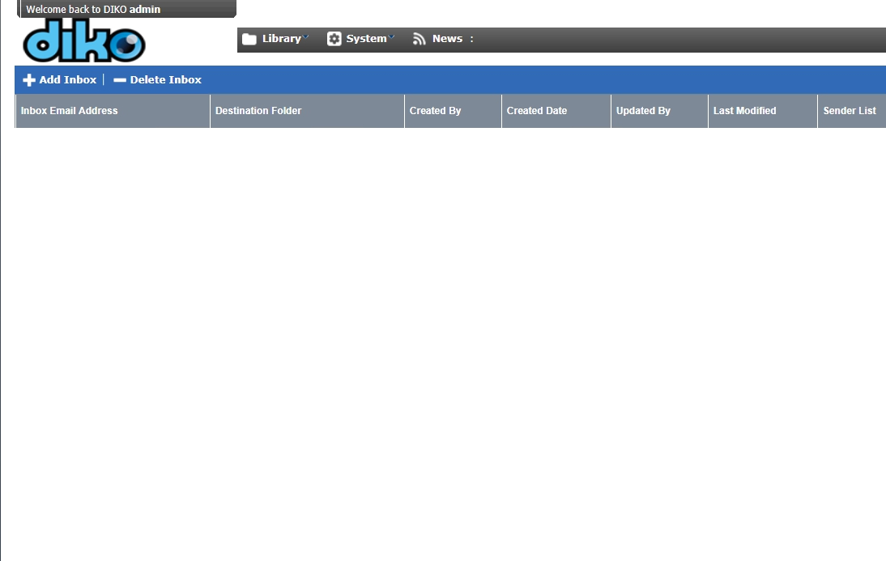

3. Fill in the information for the Receiving Inbox, also under Sender List you can choose who can send to the Receiving Inbox and have the emails filed to your desired folder path. Then click "Save" or "Update".

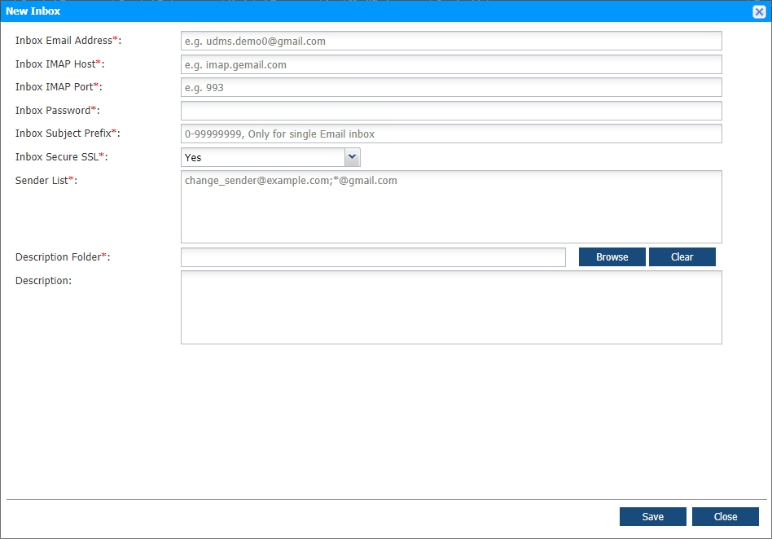

Make sure the destination folder does exist.  
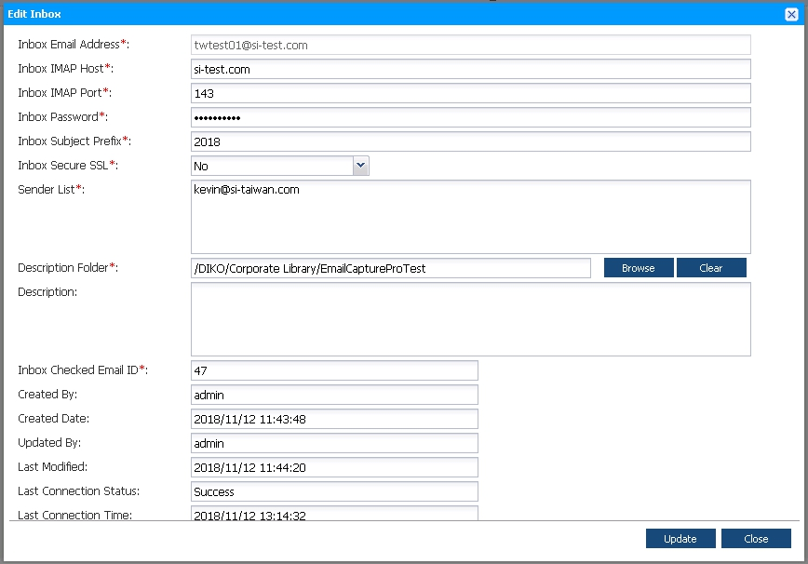

4. Send an email from the Sender List to the Receiving Inbox (Inbox Email Address)



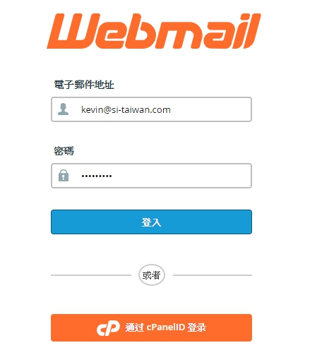

5. Sending mail to Receiving Inbox address with Subject, Message and a PDF attachment. (Must be PDF)

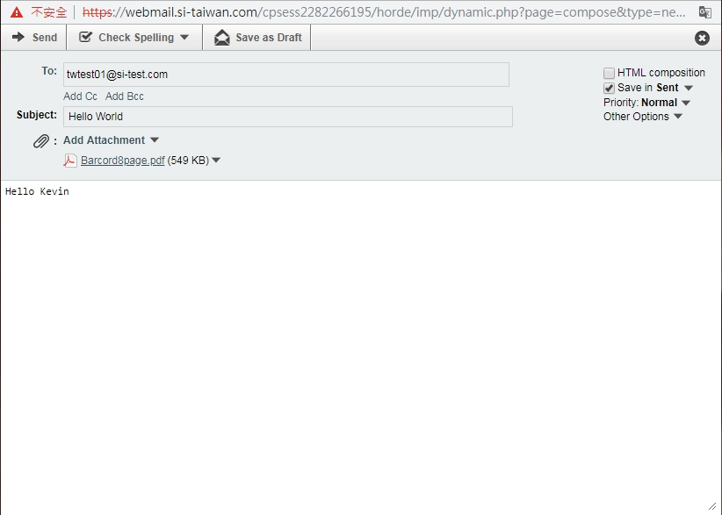

6. Received email from Sender List to Receiving Inbox, which is filed in the chosen path with the PDF attachment and message Subject, but no message content.

